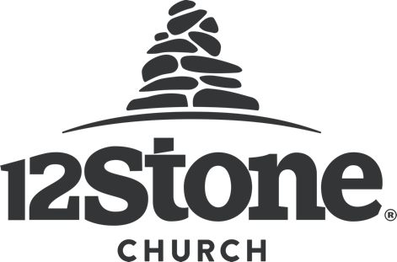

One of the sayings going around on social media amid the Coronavirus is, “After you wash your hands, wash someone’s feet.” It’s an encouragement for Christians to serve others during this time of uncertainty. Many of you have reached out already wondering how you can help, and our local co-ops are asking for your assistance to meet the community’s needs.

If you have extra of the needed items below, please fill up a bag and bring it to one of our drop-off locations this week. Starting Monday, March 23rd, we will only be collecting donations at our Buford, Braselton, Flowery Branch, Hamilton Mill, Lawrenceville, Snellville, and Sugarloaf locations. Donations can be dropped off at any time. We will have boxes located outside! Just drop and go, and we will take care of the rest!

Most Needed items:

- Jelly | - Cereal
- Peanut Butter | - Canned pasta (spaghetti-o’s)
- Deodorant | - White Rice
- Shampoo | - Taco kits
- Laundry Detergent | - Canned fruit
- Dish Soap
- Canned beans (not green beans)
- Tuna/Chicken/Spam (or any canned meats)

(If you don’t have these items but have other canned goods to spare, please bring them!)

